Nomination Form: Wiidookodaadiwin ni (Mutual Help or Helping Others) Portage la Prairie Urban Indigenous Business of the Year

Nominator Information:
Name:
Email:
Phone Number:
Relationship to Nominee (if any):
Nominee Information:

Business Name:
Phone Number:
Email:

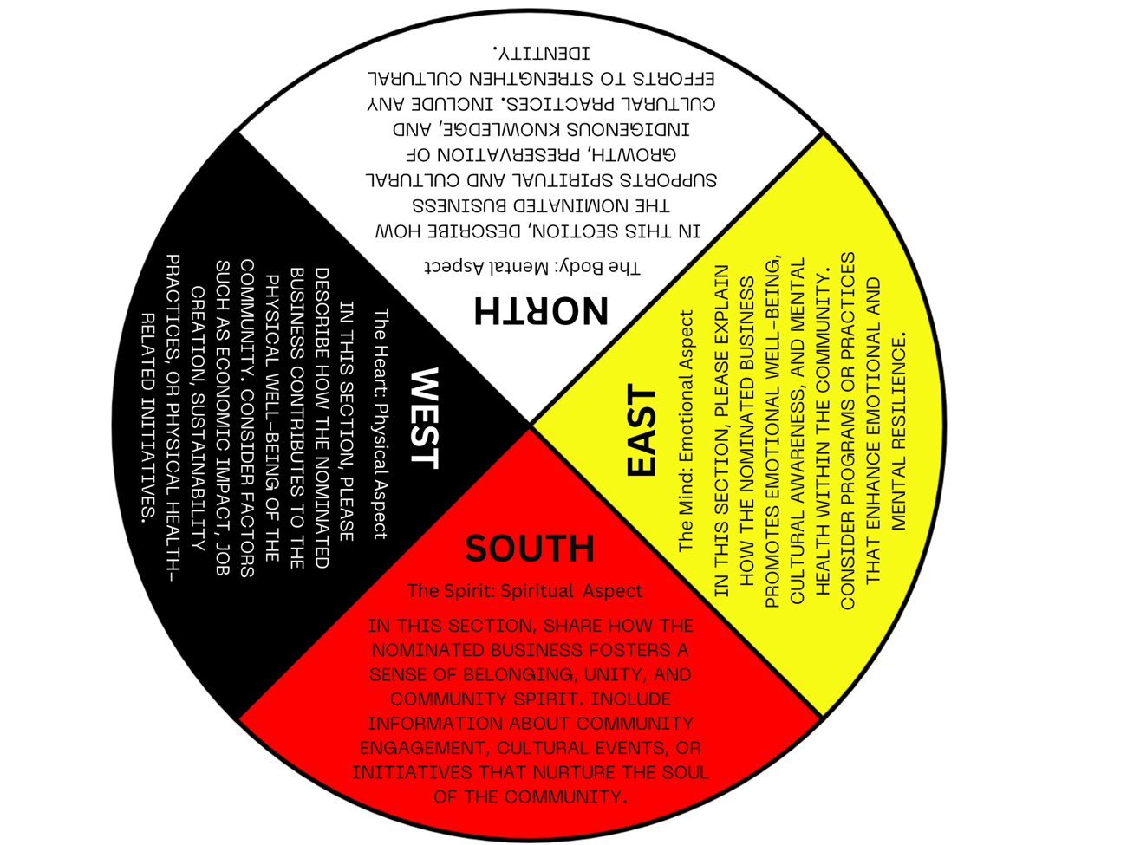

Using the criteria in the medicine wheel, please fill out the last two pages and describe how your nominee contributes to the wellbeing of the community.

Medicine Wheel Categories: (See page 3)
- Physical Aspect (North - The Body):
____________________________________________________________________________________________________________________________________________________________________________________________________________________________________________________________________________________________________________________________________________________________________________________________________________________________________________________________________________________________________________
- Emotional Aspect (East - The Mind):
______________________________________________________________________________________________________________________________________________________________________________________________________________________________________________________________________________________________________________________________________________________________________________________________________
- Mental Aspect (South - The Spirit):
____________________________________________________________________________________________________________________________________________________________________________________________________________________________________________________________________________________________________________________________________________________________________________________________________________________________________________________________________________________________________________

- 4. Spiritual Aspect (West - The Heart):
____________________________________________________________________________________________________________________________________________________________________________________________________________________________________________________________________________________________________________________________________________________________________________________________________________________________________________________________________________________________________________

Additional Information:

Provide any additional information or testimonials that support this nomination.

Declaration:
I hereby nominate the above-mentioned business for the "Urban Indigenous Business of the Year" award. I confirm that the information provided is accurate to the best of my knowledge.
Signature:

(Type Your Name):
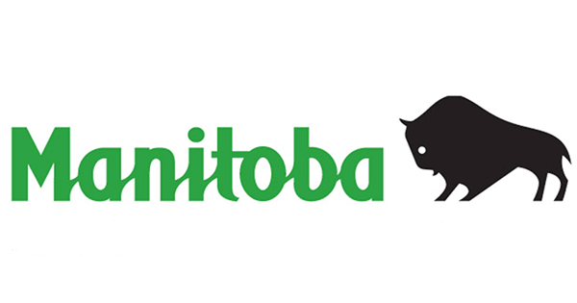
Date:

Using the criteria in the medicine wheel, please fill out the last two pages and describe how your nominee contributes to the wellbeing of the community.

